**BIT Internship**

**Program – 1 : Responsive Menu Bar**

HTML :

<!DOCTYPE html>

<html lang="en">

<head>

<meta charset="UTF-8">

<meta http-equiv="X-UA-Compatible" content="IE=edge">

<meta name="viewport" content="width=device-width, initial-scale=1.0">

<!-- ===== CSS ===== -->

<link rel="stylesheet" href="styles.css">

<!-- ===== Boxicons CSS ===== -->

<link href='https://unpkg.com/boxicons@2.1.1/css/boxicons.min.css' rel='stylesheet'>

<title>Responsive Navigation Menu Bar</title>

</head>

<body>

<nav>

<div class="nav-bar">

<i class='bx bx-menu sidebarOpen' ></i>

<span class="logo navLogo"><a href="#">Shubh Soni</a></span>

<div class="menu">

<div class="logo-toggle">

<span class="logo"><a href="#">Shubh Soni</a></span>

<i class='bx bx-x siderbarClose'></i>

</div>

<ul class="nav-links">

<li><a href="#">Home</a></li>

<li><a href="#">About</a></li>

<li><a href="#">Portfolio</a></li>

<li><a href="#">Services</a></li>

<li><a href="#">Contact</a></li>

</ul>

</div>

<div class="darkLight-searchBox">

<div class="dark-light">

<i class='bx bx-moon moon'></i>

<i class='bx bx-sun sun'></i>

</div>

<div class="searchBox">

<div class="searchToggle">

<i class='bx bx-x cancel'></i>

<i class='bx bx-search search'></i>

</div>

<div class="search-field">

<input type="text" placeholder="Search...">

<i class='bx bx-search'></i>

</div>

</div>

</div>

</div>

</nav>

<script src="script.js"></script>

</body>

</html>

CSS :

/* ===== Google Font Import - Poppins ===== */

@import url('https://fonts.googleapis.com/css2?family=Poppins:wght@300;400;500;600&display=swap');

*{

margin: 0;

padding: 0;

box-sizing: border-box;

font-family: 'Poppins', sans-serif;

transition: all 0.4s ease;;

}

/* ===== Colours ===== */

:root{

--body-color: #E4E9F7;

--nav-color: #4070F4;

--side-nav: #010718;

--text-color: #FFF;

--search-bar: #F2F2F2;

--search-text: #010718;

}

body{

height: 100vh;

background-color: var(--body-color);

}

body.dark{

--body-color: #18191A;

--nav-color: #242526;

--side-nav: #242526;

--text-color: #CCC;

--search-bar: #242526;

}

nav{

position: fixed;

top: 0;

left: 0;

height: 70px;

width: 100%;

background-color: var(--nav-color);

z-index: 100;

}

body.dark nav{

border: 1px solid #393838;

}

nav .nav-bar{

position: relative;

height: 100%;

max-width: 1000px;

width: 100%;

background-color: var(--nav-color);

margin: 0 auto;

padding: 0 30px;

display: flex;

align-items: center;

justify-content: space-between;

}

nav .nav-bar .sidebarOpen{

color: var(--text-color);

font-size: 25px;

padding: 5px;

cursor: pointer;

display: none;

}

nav .nav-bar .logo a{

font-size: 25px;

font-weight: 500;

color: var(--text-color);

text-decoration: none;

}

.menu .logo-toggle{

display: none;

}

.nav-bar .nav-links{

display: flex;

align-items: center;

}

.nav-bar .nav-links li{

margin: 0 5px;

list-style: none;

}

.nav-links li a{

position: relative;

font-size: 17px;

font-weight: 400;

color: var(--text-color);

text-decoration: none;

padding: 10px;

}

.nav-links li a::before{

content: '';

position: absolute;

left: 50%;

bottom: 0;

transform: translateX(-50%);

height: 6px;

width: 6px;

border-radius: 50%;

background-color: var(--text-color);

opacity: 0;

transition: all 0.3s ease;

}

.nav-links li:hover a::before{

opacity: 1;

}

.nav-bar .darkLight-searchBox{

display: flex;

align-items: center;

}

.darkLight-searchBox .dark-light,

.darkLight-searchBox .searchToggle{

height: 40px;

width: 40px;

display: flex;

align-items: center;

justify-content: center;

margin: 0 5px;

}

.dark-light i,

.searchToggle i{

position: absolute;

color: var(--text-color);

font-size: 22px;

cursor: pointer;

transition: all 0.3s ease;

}

.dark-light i.sun{

opacity: 0;

pointer-events: none;

}

.dark-light.active i.sun{

opacity: 1;

pointer-events: auto;

}

.dark-light.active i.moon{

opacity: 0;

pointer-events: none;

}

.searchToggle i.cancel{

opacity: 0;

pointer-events: none;

}

.searchToggle.active i.cancel{

opacity: 1;

pointer-events: auto;

}

.searchToggle.active i.search{

opacity: 0;

pointer-events: none;

}

.searchBox{

position: relative;

}

.searchBox .search-field{

position: absolute;

bottom: -85px;

right: 5px;

height: 50px;

width: 300px;

display: flex;

align-items: center;

background-color: var(--nav-color);

padding: 3px;

border-radius: 6px;

box-shadow: 0 5px 5px rgba(0, 0, 0, 0.1);

opacity: 0;

pointer-events: none;

transition: all 0.3s ease;

}

.searchToggle.active ~ .search-field{

bottom: -74px;

opacity: 1;

pointer-events: auto;

}

.search-field::before{

content: '';

position: absolute;

right: 14px;

top: -4px;

height: 12px;

width: 12px;

background-color: var(--nav-color);

transform: rotate(-45deg);

z-index: -1;

}

.search-field input{

height: 100%;

width: 100%;

padding: 0 45px 0 15px;

outline: none;

border: none;

border-radius: 4px;

font-size: 14px;

font-weight: 400;

color: var(--search-text);

background-color: var(--search-bar);

}

body.dark .search-field input{

color: var(--text-color);

}

.search-field i{

position: absolute;

color: var(--nav-color);

right: 15px;

font-size: 22px;

cursor: pointer;

}

body.dark .search-field i{

color: var(--text-color);

}

@media (max-width: 790px) {

nav .nav-bar .sidebarOpen{

display: block;

}

.menu{

position: fixed;

height: 100%;

width: 320px;

left: -100%;

top: 0;

padding: 20px;

background-color: var(--side-nav);

z-index: 100;

transition: all 0.4s ease;

}

nav.active .menu{

left: -0%;

}

nav.active .nav-bar .navLogo a{

opacity: 0;

transition: all 0.3s ease;

}

.menu .logo-toggle{

display: block;

width: 100%;

display: flex;

align-items: center;

justify-content: space-between;

}

.logo-toggle .siderbarClose{

color: var(--text-color);

font-size: 24px;

cursor: pointer;

}

.nav-bar .nav-links{

flex-direction: column;

padding-top: 30px;

}

.nav-links li a{

display: block;

margin-top: 20px;

}

}

Output :

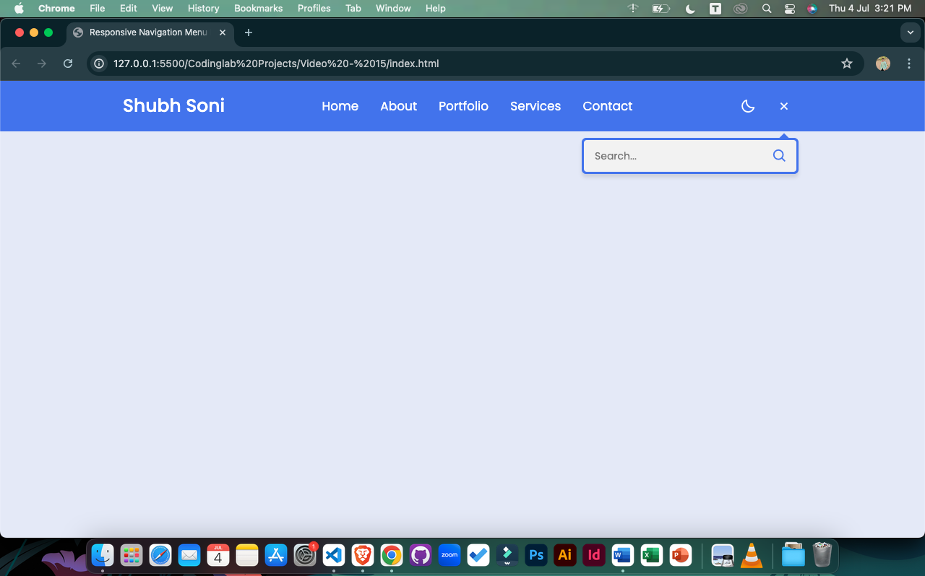

Program – 2 : 3D Flip Card On Hover

<!DOCTYPE html>

<html lang="en">

<head>

<meta charset="UTF-8">

<meta name="viewport" content="width=device-width, initial-scale=1.0">

<title>3D Flip Card on Hover</title>

<link rel="stylesheet" href="styles.css">

<!-- Boxicons CSS -->

<link href='https://unpkg.com/boxicons@2.1.4/css/boxicons.min.css' rel='stylesheet'>

</head>

<body>

<div class="wrapper">

<div class="card front-face">

<img src="profile.jpg" alt="Shubh Soni's Image">

</div>

<div class="card back-face">

<img src="profile.jpg" alt="Shubh Soni's Image">

<div class="info">

<div class="title">Shubh Soni</div>

<p>Web Developer & <br> Python Programmer</p>

</div>

<ul>

<a href="#"><i class='bx bxl-facebook' ></i></a>

<a href="#"><i class='bx bxl-instagram' ></i></a>

<a href="#"><i class='bx bxl-twitter' ></i></a>

<a href="#"><i class='bx bxl-linkedin' ></i></a>

</ul>

</div>

</div>

</body>

</html>

CSS :

@import url('https://fonts.googleapis.com/css?family=Poppins:400,500,600,700&display=swap');

*{

margin: 0;

padding: 0;

box-sizing: border-box;

font-family: 'Poppins', sans-serif;

}

html,body{

display: grid;

height: 100%;

width: 100%;

place-items: center;

background: linear-gradient(375deg, #1cc7d0, #2ede98);

}

::selection{

color: #fff;

background: #1cc7d0;

}

.wrapper{

height: 400px;

width: 320px;

position: relative;

transform-style: preserve-3d;

perspective: 1000px;

}

.wrapper .card{

position: absolute;

height: 100%;

width: 100%;

padding: 5px;

background: #fff;

border-radius: 10px;

transform: translateY(0deg);

transform-style: preserve-3d;

backface-visibility: hidden;

box-shadow: 0px 10px 15px rgba(0,0,0,0.1);

transition: transform 0.7s cubic-bezier(0.4,0.2,0.2,1);

}

.wrapper:hover > .front-face{

transform: rotateY(-180deg);

}

.wrapper .card img{

height: 100%;

width: 100%;

object-fit: cover;

border-radius: 10px;

}

.wrapper .back-face{

display: flex;

align-items: center;

justify-content: space-evenly;

flex-direction: column;

transform: rotateY(180deg);

}

.wrapper:hover > .back-face{

transform: rotateY(0deg);

}

.wrapper .back-face img{

height: 150px;

width: 150px;

padding: 5px;

border-radius: 50%;

background: linear-gradient(375deg, #1cc7d0, #2ede98);

}

.wrapper .back-face .info{

text-align: center;

}

.back-face .info .title{

font-size: 30px;

font-weight: 500;

}

.back-face ul{

display: flex;

}

.back-face ul a{

display: block;

height: 40px;

width: 40px;

color: #fff;

text-align: center;

margin: 0 5px;

line-height: 38px;

border: 2px solid transparent;

border-radius: 50%;

background: linear-gradient(375deg, #1cc7d0, #2ede98);

transition: all 0.5s ease;

}

.back-face ul a:hover{

color: #1cc7d0;

border-color: #1cc7d0;

background: linear-gradient(375deg, transparent, transparent);

}

Output :

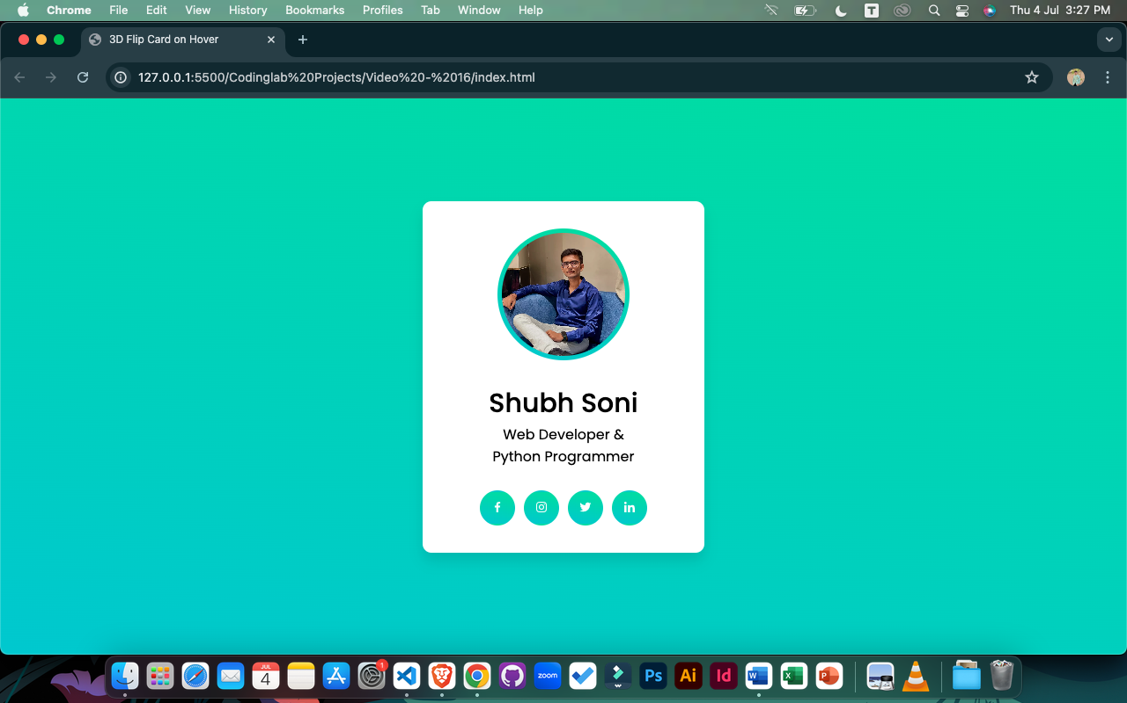

Program – 3 : Animated Image Gallery

<!DOCTYPE html>

<html lang="en" dir="ltr">

<head>

<meta charset="UTF-8">

<title> Animated Image Gallery | CodingLab </title>

<link rel="stylesheet" href="style.css">

<link rel="stylesheet" href="https://cdnjs.cloudflare.com/ajax/libs/font-awesome/5.15.2/css/all.min.css"/>

</head>

<body>

<div class="container">

<input type="radio" name="s" id="home" checked>

<input type="radio" name="s" id="blog">

<input type="radio" name="s" id="code">

<input type="radio" name="s" id="help">

<input type="radio" name="s" id="about">

<nav>

<div class="slider"></div>

<label class="home" for="home">

<i class="fas fa-home"></i>Home

</label>

<label class="blog" for="blog">

<i class="fas fa-blog"></i>Blog

</label>

<label class="code" for="code">

<i class="fas fa-code"></i>Code

</label>

<label class="help" for="help">

<i class="fas fa-envelope"></i>Help

</label>

<label class="about" for="about">

<i class="fas fa-user"></i>About

</label>

</nav>

</div>

</body>

</html>

CSS :

@import url('https://fonts.googleapis.com/css2?family=Poppins:wght@200;300;400;500;600;700&display=swap');

*{

margin: 0;

padding: 0;

box-sizing: border-box;

font-family: 'Poppins',sans-serif;

}

body{

height: 100vh;

width: 100%;

display: flex;

justify-content: center;

align-items: center;

background: #f2f2f2;

}

nav{

width: 600px;

height: 60px;

border-radius: 5px;

display: flex;

text-align: center;

position: relative;

background: #fff;

box-shadow: 0 5px 10px rgba(0, 0, 0, 0.25);

}

nav label{

width: 100%;

height: 100%;

line-height: 60px;

font-size: 18px;

font-weight: 400;

border-radius: 5px;

margin: 0 5px;

color: #8e44ad;

position: relative;

z-index: 1;

cursor: pointer;

transition: all 0.3s ease;

}

nav label:hover{

background: rgba(142, 68, 173, 0.3);

}

nav label i{

margin-right: 4px;

}

nav .slider{

position: absolute;

height: 100%;

width: 20%;

background: #8e44ad;

left: 0;

top: 0;

border-radius: 5px;

transition: all 0.4s cubic-bezier(0.68, -0.55, 0.265, 1.55);

z-index: 1;

}

#home:checked ~ nav label.home,

#blog:checked ~ nav label.blog,

#code:checked ~ nav label.code,

#help:checked ~ nav label.help,

#about:checked ~ nav label.about{

color: #fff;

}

#blog:checked ~ nav .slider{

left: 20%;

}

#code:checked ~ nav .slider{

left: 40%;

}

#help:checked ~ nav .slider{

left: 60%;

}

#about:checked ~ nav .slider{

left: 80%;

}

input[type=radio]{

display: none;

}

Output :

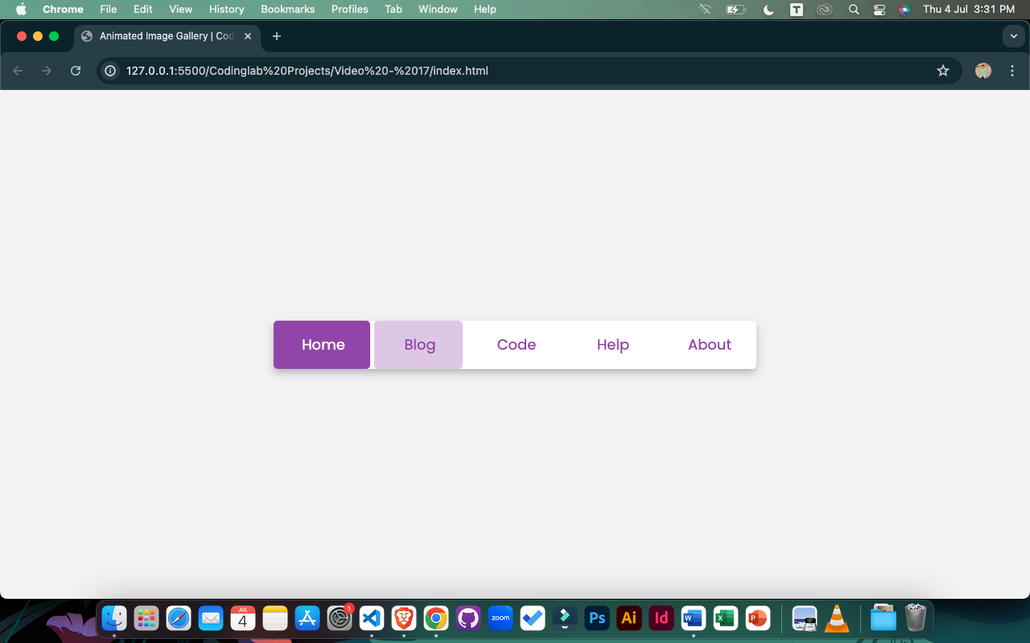

Program – 4 : Login Form

<!DOCTYPE html>

<html lang="en" dir="ltr">

<head>

<meta charset="UTF-8">

<title> Login Form | CodingLab </title>

<link rel="stylesheet" href="style.css">

<link rel="stylesheet" href="https://cdnjs.cloudflare.com/ajax/libs/font-awesome/5.15.2/css/all.min.css"/>

</head>

<body>

<div class="main_div">

<div class="title">Login Form</div>

<div class="social_icons">

<a href="#"><i class="fab fa-facebook-f"></i> <span>Facebook</span></a>

<a href="#"><i class="fab fa-twitter"></i><span>Twitter</span></a>

</div>

<form action="#">

<div class="input_box">

<input type="text" placeholder="Email or Phone" required>

<div class="icon"><i class="fas fa-user"></i></div>

</div>

<div class="input_box">

<input type="password" placeholder="Password" required>

<div class="icon"><i class="fas fa-lock"></i></div>

</div>

<div class="option_div">

<div class="check_box">

<input type="checkbox">

<span>Remember me</span>

</div>

<div class="forget_div">

<a href="#">Forgot password?</a>

</div>

</div>

<div class="input_box button">

<input type="submit" value="Login">

</div>

<div class="sign_up">

Not a member? <a href="#">Signup now</a>

</div>

</form>

</div>

</body>

</html>

CSS :

*{

margin: 0;

padding: 0;

box-sizing: border-box;

font-family: 'Poppins',sans-serif;

}

html,body{

display: grid;

height: 100vh;

place-items:center;

background: #be2edd;

}

.main_div{

width: 365px;

background: #fff;

padding: 30px;

border-radius: 5px;

box-shadow: 5px 5px 10px rgba(0, 0, 0, 0.15);

}

.main_div .title{

text-align: center;

font-size: 30px;

font-weight: 600;

}

.main_div .social_icons{

margin-top: 20px;

display: flex;

justify-content: center;

}

.social_icons a{

display: block;

height: 45px;

width: 100%;

line-height: 45px;

text-align: center;

border-radius: 5px;

font-size: 20px;

color: #fff;

text-decoration: none;

transition: all 0.3s linear;

}

.social_icons a span{

margin-left: 5px;

font-size: 18px;

}

.social_icons a:first-child{

margin-right: 5px;

background: #4267B2;

}

.social_icons a:first-child:hover{

background: #375695;

}

.social_icons a:last-child{

margin-left: 5px;

background: #1DA1F2;

}

.social_icons a:last-child:hover{

background: #0d8bd9;

}

form {

margin-top: 25px;

}

form .input_box{

height: 50px;

width: 100%;

position: relative;

margin-top: 15px;

}

.input_box input{

height: 100%;

width: 100%;

outline: none;

border: 1px solid lightgrey;

border-radius: 5px;

padding-left: 45px;

font-size: 17px;

transition: all 0.3s ease;

}

.input_box input:focus{

border-color: #be2edd;

}

.input_box .icon{

position: absolute;

top: 50%;

left: 20px;

transform: translateY(-50%);

color: grey;

}

form .option_div{

margin-top: 5px;

display: flex;

justify-content: space-between;

}

.option_div .check_box{

display: flex;

align-items: center;

}

.option_div span{

margin-left: 5px;

font-size: 16px;

color: #333;

}

.option_div .forget_div a{

font-size: 16px;

color: #be2edd;

}

.button input{

padding-left: 0;

background: #be2edd;

color: #fff;

border: none;

font-size: 20px;

font-weight: 500;

cursor: pointer;

transition: all 0.3s linear;

}

.button input:hover{

background: #a720c5;

}

form .sign_up{

text-align: center;

margin-top: 25px;

}

.sign_up a{

color: #be2edd;

}

form a{

text-decoration: none;

}

form a:hover{

text-decoration: underline;

}

Output :

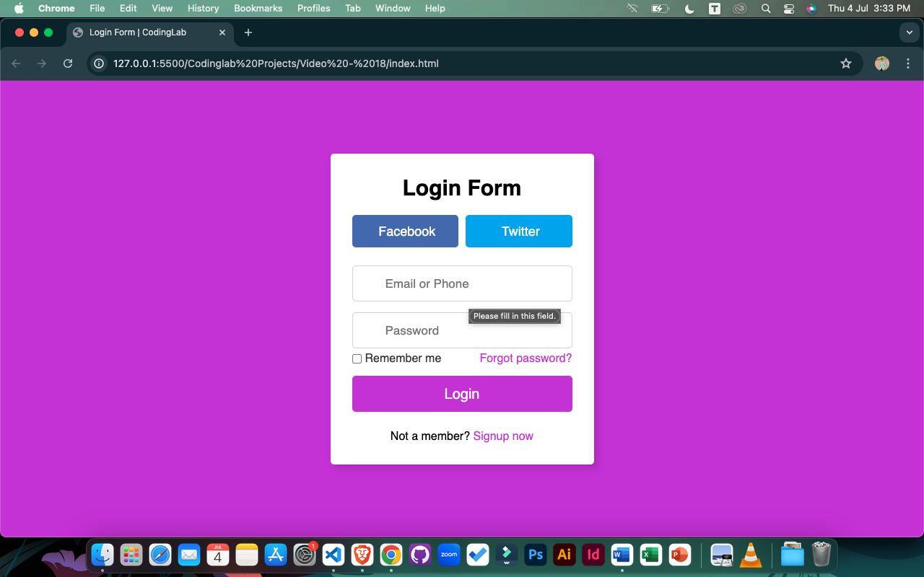

Program – 5 : Loading Spinner

<!DOCTYPE html>

<html lang="en">

<head>

<meta charset="UTF-8">

<meta name="viewport" content="width=device-width, initial-scale=1.0">

<title>Loading Spinner</title>

<link rel="stylesheet" href="style.css">

</head>

<body>

<section>

<div class="dots">

<span style="--i:1"></span>

<span style="--i:2"></span>

<span style="--i:3"></span>

<span style="--i:4"></span>

<span style="--i:5"></span>

<span style="--i:6"></span>

<span style="--i:7"></span>

<span style="--i:8"></span>

<span style="--i:9"></span>

<span style="--i:10"></span>

<span style="--i:11"></span>

<span style="--i:12"></span>

<span style="--i:13"></span>

<span style="--i:14"></span>

<span style="--i:15"></span>

</div>

</section>

</body>

</html>

CSS :

*{

margin: 0;

padding: 0;

box-sizing: border-box;

}

section{

display: flex;

height: 100vh;

width: 100%;

align-items: center;

justify-content: center;

background: #4070f4;

}

section .dots span{

position: absolute;

height: 10px;

width: 10px;

background: #fff;

border-radius: 50%;

transform: rotate(calc(var(--i) * (360deg / 15))) translateY(35px);

animation: animate 1.5s linear infinite;

animation-delay: calc(var(--i) * 0.1s);

opacity: 1;

}

@keyframes animate {

0%{

opacity: 1;

}

100%{

opacity: 0;

}

}

Output :

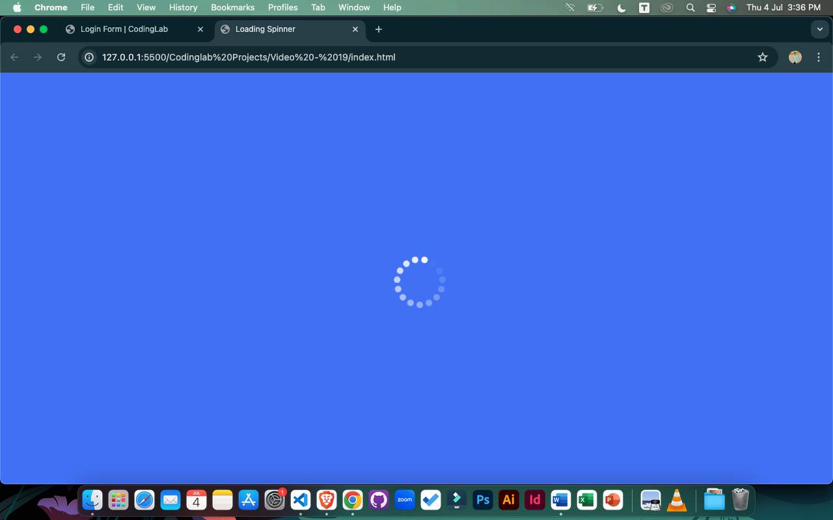

Program – 6 : Image Hover Animation HTML & CSS

<!DOCTYPE html>

<html lang="en" dir="ltr">

<head>

<meta charset="UTF-8" />

<title>Image Hover Animation HTML CSS</title>

<link rel="stylesheet" href="style.css" />

</head>

<body>

<div class="container">

<div class="icon-image">

<div class="icon">

<img src="profile.jpg" alt="" />

</div>

<div class="hover-image one">

<div class="img">

<img src="profile.jpg" alt="" />

</div>

<div class="content">

<div class="details">

<div class="name">David Marloo</div>

<div class="job">Designer || Developer</div>

</div>

</div>

</div>

</div>

<div class="icon-image">

<div class="icon">

<img src="profile.jpg" alt="" />

</div>

<div class="hover-image one">

<div class="img">

<img src="profile.jpg" alt="" />

</div>

<div class="content">

<div class="details">

<div class="name">Lilly Carls</div>

<div class="job">Blogger || Designer</div>

</div>

</div>

</div>

</div>

<div class="icon-image">

<div class="icon">

<img src="profile.jpg" alt="" />

</div>

<div class="hover-image one">

<div class="img">

<img src="profile.jpg" alt="" />

</div>

<div class="content">

<div class="details">

<div class="name">Stephen Bald</div>

<div class="job">Designer || Developer</div>

</div>

</div>

</div>

</div>

<div class="icon-image">

<div class="icon">

<img src="profile.jpg" alt="" />

</div>

<div class="hover-image one">

<div class="img">

<img src="profile.jpg" alt="" />

</div>

<div class="content">

<div class="details">

<div class="name">Mike Tyson</div>

<div class="job">Photographer || Youtuber</div>

</div>

</div>

</div>

</div>

<div class="icon-image">

<div class="icon">

<img src="profile.jpg" alt="" />

</div>

<div class="hover-image one">

<div class="img">

<img src="profile.jpg" alt="" />

</div>

<div class="content">

<div class="details">

<div class="name">Emma Oliva</div>

<div class="job">Developer || Designer</div>

</div>

</div>

</div>

</div>

<div class="icon-image last">

<div class="icon">

<img src="profile.jpg" alt="" />

</div>

<div class="hover-image one">

<div class="img">

<img src="profile.jpg" alt="" />

</div>

<div class="content">

<div class="details">

<div class="name">Shubh Soni</div>

<div class="job">Blogger || Youtuber</div>

</div>

</div>

</div>

</div>

</div>

</body>

</html>

CSS :

@import url('https://fonts.googleapis.com/css2?family=Poppins:wght@200;300;400;500;600;700&display=swap');

*{

margin: 0;

padding: 0;

box-sizing: border-box;

font-family: 'Poppins',sans-serif;

}

body{

height: 100vh;

width: 100%;

display: flex;

justify-content: center;

align-items: center;

background: #0396FF;

}

.container{

height: 500px;

display: flex;

min-width: 400px;

align-items: flex-end;

justify-content: center;

margin-top: -55px;

}

.icon-image{

position: relative;

height: 70px;

width: 70px;

margin: 0 5px;

cursor: pointer;

box-shadow: 0 5px 10px rgba(0, 0, 0, 0.25);

border-radius: 50%;

background: #fff;

}

.icon-image .icon img{

position: absolute;

height: 95%;

width: 95%;

left: 50%;

top: 50%;

transform: translate(-50%, -50%);

object-fit: cover;

border-radius: 50%;

border: 3px solid #0396FF;

}

.icon-image::before{

content: '';

position: absolute;

width: 50px;

height: 50px;

left: 50%;

top: -50px;

transform: translateX(-50%);

}

.icon-image .hover-image{

position: absolute;

height: 350px;

width: 300px;

bottom: 100px;

left: 50%;

z-index: 0;

transform: translateX(-50%);

border-radius: 25px;

pointer-events: none;

box-shadow: 0 5px 10px rgba(0, 0, 0, 0.15);

transition: transform 0.5s ease, z-index 0s, left 0.5s ease ;

transition-delay: 0s, 0.5s, 0.5s;

}

.icon-image:hover .hover-image{

left: -200px;

z-index: 12;

transform: translateX(80px);

transition: left 0.5s ease, z-index 0s, transform 0.5s ease;

transition-delay: 0s, 0.5s, 0.5s;

}

.hover-image img{

position: absolute;

height: 100%;

width: 100%;

object-fit: cover;

border: 3px solid #fff;

border-radius: 25px;

}

.hover-image .content{

position: absolute;

width: 100%;

bottom: -10px;

padding: 0 10px;

}

.content::before{

content: '';

position: absolute;

height: 20px;

width: 20px;

background: #fff;

left: 50%;

bottom: -7px;

transform: rotate(45deg) translateX(-50%);

z-index: -1;

}

.content .details{

position: relative;

background: #fff;

padding: 10px;

border-radius: 12px;

text-align: center;

opacity: 0;

pointer-events: none;

transform: translateY(10px);

}

.icon-image:hover .details{

transition: all 0.5s ease;

transition-delay: 0.9s;

opacity: 1;

transform: translateY(4px);

pointer-events: auto;

}

.details::before{

content: '';

position: absolute;

height: 20px;

width: 20px;

background: #fff;

left: 50%;

bottom: -15px;

transform: rotate(45deg) translateX(-50%);

z-index: -1;

}

.content .details .name{

font-size: 20px;

font-weight: 500;

}

.content .details .job{

font-size: 17px;

color: #0396FF;

margin: -3px 0 5px 0;

}

.content .details a:hover{

color: #0396FF;

}

.container .last .hover-image{

transition: none;

}

.container .last:hover .hover-image{

transition: 0;

}

.last:hover .details{

transition-delay: 0s;

}

Output :

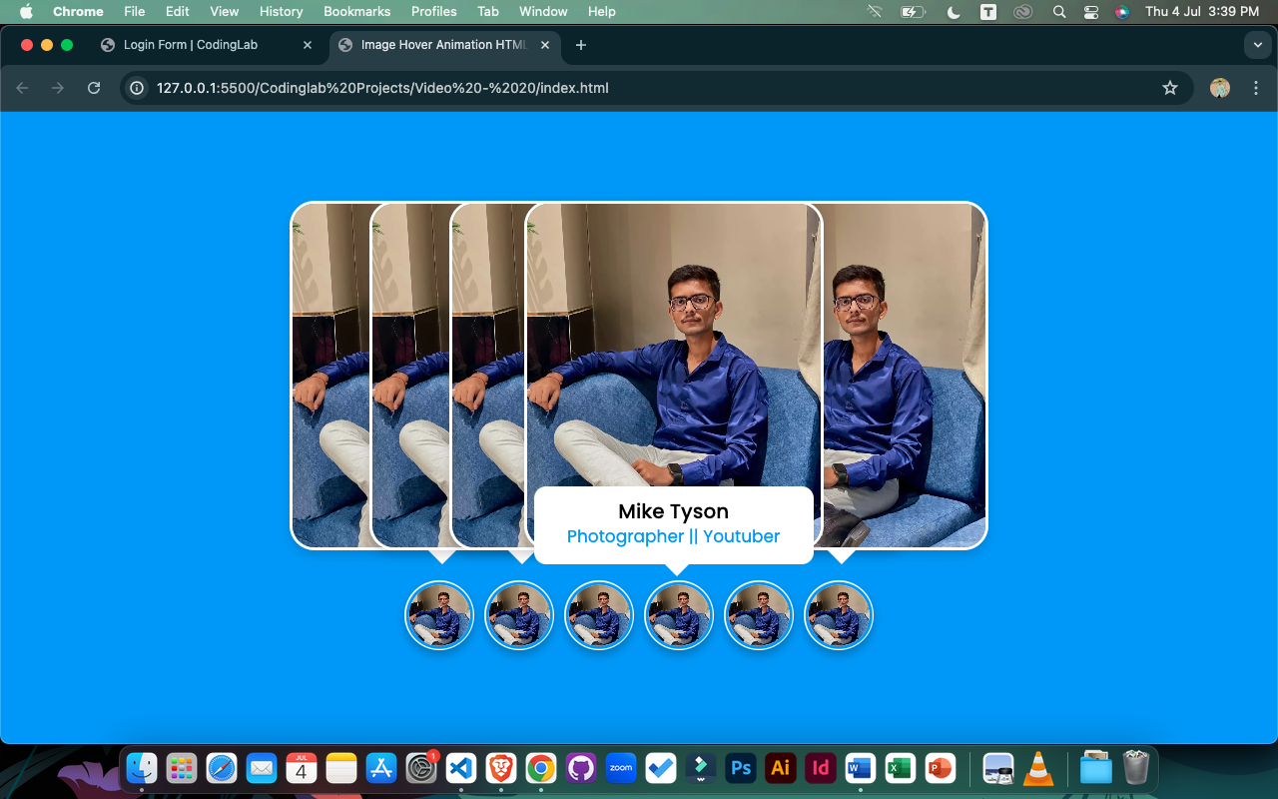

Program – 7 : Animated Skills Bar

<!DOCTYPE html>

<html lang="en">

<head>

<meta charset="UTF-8">

<meta http-equiv="X-UA-Compatible" content="IE=edge">

<meta name="viewport" content="width=device-width, initial-scale=1.0">

<!----======== CSS ======== -->

<link rel="stylesheet" href="style.css">

<title>Animated Skills Bar</title>

</head>

<body>

<div class="container">

<div class="skill-box">

<span class="title">HTML</span>

<div class="skill-bar">

<span class="skill-per html">

<span class="tooltip">90%</span>

</span>

</div>

</div>

<div class="skill-box">

<span class="title">CSS</span>

<div class="skill-bar">

<span class="skill-per css">

<span class="tooltip">70%</span>

</span>

</div>

</div>

<div class="skill-box">

<span class="title">JavaScript</span>

<div class="skill-bar">

<span class="skill-per javascript">

<span class="tooltip">50%</span>

</span>

</div>

</div>

<div class="skill-box">

<span class="title">NodeJS</span>

<div class="skill-bar">

<span class="skill-per nodejs">

<span class="tooltip">30%</span>

</span>

</div>

</div>

</div>

</body>

</html>

CSS :

/* ===== Google Font Import - Poppins ===== */

@import url('https://fonts.googleapis.com/css2?family=Poppins:wght@200;300;400;500;600&display=swap');

*{

margin: 0;

padding: 0;

box-sizing: border-box;

font-family: 'Poppins', sans-serif;

}

body{

height: 100vh;

display: flex;

background: #4070f4;

align-items: center;

justify-content: center;

}

.container{

position: relative;

max-width: 500px;

width: 100%;

background: #fff;

margin: 0 15px;

padding: 10px 20px;

border-radius: 7px;

}

.container .skill-box{

width: 100%;

margin: 25px 0;

}

.skill-box .title{

display: block;

font-size: 14px;

font-weight: 600;

color: #333;

}

.skill-box .skill-bar{

height: 8px;

width: 100%;

border-radius: 6px;

margin-top: 6px;

background: rgba(0,0,0,0.1);

}

.skill-bar .skill-per{

position: relative;

display: block;

height: 100%;

width: 90%;

border-radius: 6px;

background: #4070f4;

animation: progress 0.4s ease-in-out forwards;

opacity: 0;

}

.skill-per.css{

width: 70%;

animation-delay: 0.1s;

}

.skill-per.javascript{

width: 50%;

animation-delay: 0.2s;

}

.skill-per.nodejs{

width: 30%;

animation-delay: 0.3s;

}

@keyframes progress {

0%{

width: 0;

opacity: 1;

}

100%{

opacity: 1;

}

}

.skill-per .tooltip{

position: absolute;

right: -14px;

top: -28px;

font-size: 9px;

font-weight: 500;

color: #fff;

padding: 2px 6px;

border-radius: 3px;

background: #4070f4;

z-index: 1;

}

.tooltip::before{

content: '';

position: absolute;

left: 50%;

bottom: -2px;

height: 10px;

width: 10px;

z-index: -1;

background-color: #4070f4;

transform: translateX(-50%) rotate(45deg);

}

Output :

